1.

Q : What is a computer?

A : In its bare definitions a computer is a device made to store, process, and display data as needed by the user. from desktops to phones and all the way to abaccus: all are considered computers.

2.

Q : What are the essential parts of a computer?

A : What i would consider to be essential parts of a computer is first the computer itself in all its many parts in the power source, motherboard, storage unit, etc

As well as a way to interact with the computer or the mouse and keyboard,

and finally a way to display it such as the monitors.

3.

Q : Who are the notable inventors of hardware and software? cite at least 5 software developers and 5 hardware developers

A :

Hardware:

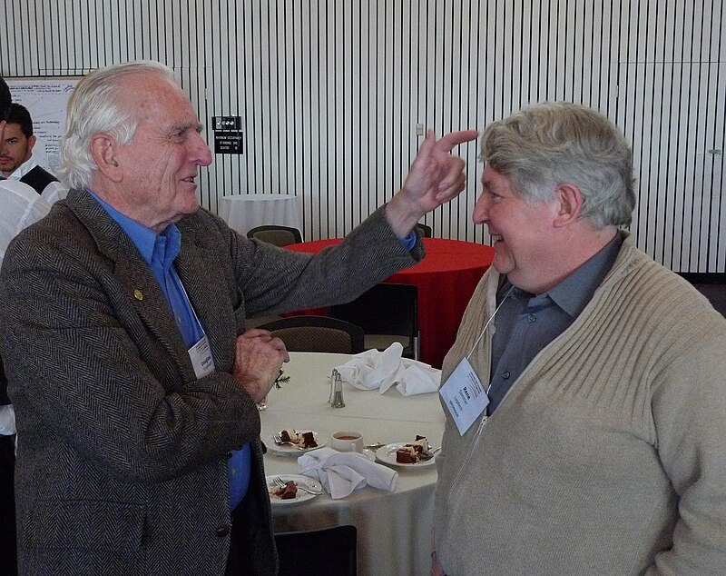

(a photo of Rene Sommer and Douglas Engelbart)

My most notable and i think underrated names in the hardware game is

American engineer **"Douglas Englebert"** with his co-inventor: swiss computer programmer **"Rene Sommer", "Jean-Daniel Nicoud", and "Andre Guignard"** or the team behind **The Mouse.**

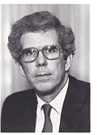

(Philip Don Estridge)

and another one would be **"Philip Don Estrige" or Don estridge** who's also known as **"The father of IBM"** or the computers behind our history that was used by the government to handle all sorts of things from aeronautical, defense systems, and the IBM 7094 which was used to have robots sing for the first time.

Software :

For software developers the people that stuck out to me the most has to be

the face of facebook himself Mr **"Mark Zuckerberg"** practically the man behind 20th century streamlined social media that exploded what its predecessors "friendster", "myspace" and other websites couldn't.

Another big name would be **"Bill Gates"** and **"Paul G. Allen"**. the two people behind **Microsoft**. the leading software aside from our other competitor:

**"Tim Cook"** or the head behind Apple.

Although not as revolutionary as the others, **"Elon Musk"** deserves a spot on this list for as of today he's spearheading the AI race to its capacity and it is obviously the next step into our technology.

4.

Q : Cite your references

A :

Britannica :

Swaine, Michael R. , Hemmendinger, David , Pottenger, William Morton and Freiberger, Paul A.. "computer". Encyclopedia Britannica, 4 Jul. 2024, https://www.britannica.com/technology/computer. Accessed 14 August 2024.

Hall, Mark. "Douglas Engelbart". Encyclopedia Britannica, 28 Jun. 2024, https://www.britannica.com/biography/Douglas-Engelbart. Accessed 14 August 2024.

Britannica, The Editors of Encyclopaedia. "Mark Zuckerberg." Encyclopedia Britannica, 13 Aug. 2024, https://www.britannica.com/money/Mark-Zuckerberg. Accessed 14 August 2024.

Gregersen, Erik. "Tim Cook." Encyclopedia Britannica, 19 Jul. 2024, https://www.britannica.com/money/Tim-Cook. Accessed 14 August 2024.

Britannica, The Editors of Encyclopaedia. "Microsoft Windows". Encyclopedia Britannica, 11 Aug. 2024, https://www.britannica.com/technology/Microsoft-Windows. Accessed 14 August 2024.

wiki :

https://en.wikipedia.org/wiki/Ren%C3%A9_Sommer

https://en.wikipedia.org/wiki/Philip_Don_Estridge